**SYNOPSIS**

**Report on**

**INVENTORY MANAGEMENT SYSTEM**

**By**

**Riya Goyal**

**2200290140127**

**Session:2023-2024 (III Semester)**

Under the supervision of

**Ms. Komal Salgotra**

### KIET Group of Institutions, Delhi-NCR, Ghaziabad



### Department Of Computer Applications

**KIET GROUP OF INSTITUTIONS, DELHI-NCR, GHAZIABAD-201206**

( 2023-2024)

**ABSTRACT**

The purpose of the Inventory Management System is to output a manual system using computer equipment and full-fledged computer software, meeting their requirements so that their valuable data/information can be preserved for a longer period of time with easy access and manipulation. The required software and hardware are readily available and easy to work with.

An inventory management system as described above can lead to a flawless, safe, reliable and fast management system. It can help the user focus more on their other record keeping activities. Thus, the organization can maintain computer records without redundant records. It can help the user to focus on other activities rather than focusing on record keeping. This will help the organization make better use of resources.

Every organization, be it a mistake or a small one, has a problem to overcome and manage information about inventory, inventory, sales, products, categories, customers. Every inventory management system has different inventory needs, so we design exclusive employee management systems that are tailored to your management requirements. This is designed to aid your strategic planning and help ensure your organization is equipped with the right level of information and detail for your future goals. Basically, this project describes how to manage for good performance and better service for the client.

**TABLE OF CONTENTS**

Page Number

1. Introduction --
2. Literature Review --
3. Project / Research Objective --
4. Project Flow/ Research Methodology --
5. Project / Research Outcome --
6. Proposed Time Duration --

References/ Bibliography --

**INTRODUCTION**

"Inventory Management System" was developed to overcome the problem prevalent in the practical manual system. This software is intended to eliminate and in some cases reduce the difficulties faced by this existing system. In addition, this system is designed for the specific needs of the company, so that operations run smoothly and efficiently.

The application is reduced as much as possible so that there are no errors when entering data. It also provides an error message when entering invalid data. No format knowledge is required to use this system. All this proves that it is user-friendly. An inventory management system as described above can lead to a flawless, safe, reliable and fast management system. It can help the user to focus on other activities rather than focusing on record keeping. This will help the organization to use resources better. It supports multiple locations or warehouses, includes data backup and recovery mechanisms, and ultimately enables businesses to reduce operating costs, improve customer service, and increase profitability by streamlining inventory processes and facilitating data-driven decision-making.

Every organization, whether it is a mistake or a small one, has a problem to overcome and manage information about inventory, inventory, sales, products, categories, customers. Every inventory management system has different inventory needs, so we design exclusive employee management systems that are tailored to your management requirements. This is designed to aid your strategic planning and help ensure your organization is equipped with the right level of information and detail for your future goals. Also for those busy managers who are always on the go, our systems come with remote access features that allow you to manage your workforce anytime, anywhere. These systems will ultimately allow you to better manage your resources.

**LITERATURE REVIEW**

Products are considered as the business resources for the organization. This includes managing the product with appropriate way to review any time as per the requirement. Therefore it is important to have a computer based IMS which has the ability to generate reports, maintain the balance of the stock, details about the purchase and sales in the organization. Before developing this application we came up with Inventory Management System existing in the market, which helps to give the knowledge for the development of our project.

These application software are only used by the large organization but so we came up with the application which can be used by the small company for the management of their stock in the production houses. After analysing the other inventory management system we decided to include some of common and key features that should be included in every inventory management system. So we decided to include those things that help the small organization in away or other

**Objective of the Project**

**Primary objective**

The main objectives of the project are listed below:

* Fulfilling the requirement to achieve the bachelor's degree Computer Information System.
* Know the basics of .Net technology and Visual Studio with the .Net Framework interface

**Secondary objective**

The secondary objectives of this project are listed below:

* Develop an application that addresses the day-to-day requirements of any manufacturing organization
* Develop easy inventory management
* To process inventory details such as sales details, purchase details and stock status details.
* To provide the organization with a competitive advantage.
* Provide detailed information on inventory status.
* Facilitate inventory management and simplify the use of inventory in the organization.

**Features of Project**

This application is used to show the stock remaining and details about the sales and purchase. It gives the details about the stock on daily based and weekly based. The details components are described below:-

**Login page:**

After launching the application, a login page will appear. An administrator login is defined by a username and password that has full authority to clear and reset password as per the requirements.

**Create Godwom:**

We can create a godwom if we need to expand or have more than one godwom. We can create a godwom along with the date.

**Sales details:**

It show the details about the sales and the remaining stock of sales. It also show the details about the sales in return.

**Purchase details:**

It shows the details about the purchase made by the organization along with the price and dates

**PROJECT FLOW**

Process Flow Diagram or Flowchart is a diagram which uses geometric symbols and arrows to define the relationships. It is a diagrammatic representation of the algorithm.

The Process flow Diagram of our application is shown below:

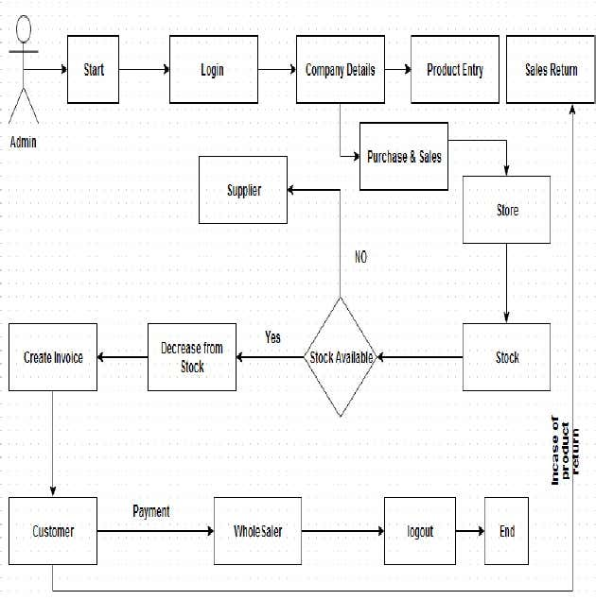

**Use Case Diagram**

Its purpose is to present a graphical overview of the functionality provided by a system in terms of actors and their goals. The main purpose of a use case diagram is to show what system functions are performed for which actors.

**Diagram Building BlockUse cases**

A use case describes a sequence of actions that provide something of measurablevalue to an actor and is drawn as a horizontal ellipse.

**Actor**

An actor is a person, organization or external system that plays a role in one or moreinteractions with the system

**System boundary boxes (optional)**

A rectangle is drawn around the use case called the system boundary box to indicatescope of the system.

**Actor**



**User Case**



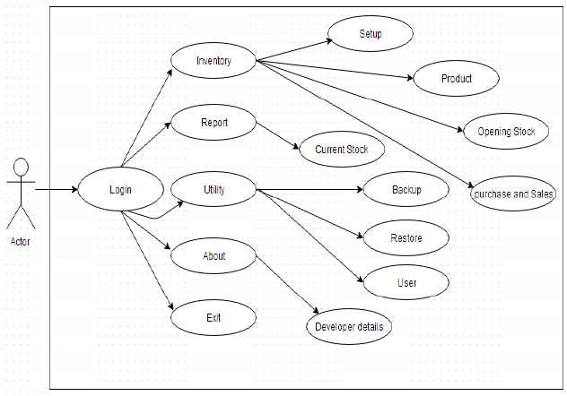IMS Use Case Diagram

**Proposed Time Duration**

The proposed time duration for an Inventory Management System (IMS) project using C#.NET can vary significantly depending on several factors. These factors include the complexity of the project, the size and scope of the organization, the customization required, the availability of resources, and the specific goals and functionalities of the IMS.

Here are some general guidelines for estimating the time duration of such a project:

**Small to Medium-Sized Business (SMB):**

For a relatively straightforward IMS implementation in a small to medium-sized business, the project might take anywhere from 3 to 6 months. This timeframe includes requirements gathering, system design, development, testing, training, and deployment.

**Large Enterprise:**

Larger enterprises with more complex operations, multiple locations, and extensive customization needs may require a longer implementation period. Such projects can range from 6 months to a year or more.

**Off-the-Shelf vs. Custom Solution:**

The choice between using an off-the-shelf IMS solution and developing a custom system can significantly impact the project duration. Custom solutions tend to take longer due to the need for extensive coding and testing.

**Resource Availability:**

The availability of skilled developers and project team members can influence the project timeline. Adequate staffing and resource allocation can expedite the development process.

**Project Complexity:**

The complexity of the IMS, including the number of features, integration requirements, and data migration, will impact the project duration. More complex systems naturally require more time.

**Testing and Quality Assurance:**

Rigorous testing and quality assurance are essential for an IMS project to ensure data accuracy and system reliability. Adequate time must be allocated for this phase.

**Training and User Adoption:**

Training users and ensuring successful adoption of the new system is a critical part of the project. Depending on the number of users and their familiarity with the system, this phase can take several weeks to months.

**Post-Implementation Evaluation:**

After the IMS is deployed, it's important to monitor its performance and gather user feedback. This phase may continue for an extended period to fine-tune the system based on real-world usage.

It's crucial to conduct a thorough project planning and feasibility study to estimate the project's time duration accurately. Additionally, project managers should consider contingencies for unexpected delays and allocate resources effectively to ensure a successful IMS implementation. The proposed time duration should align with the organization's strategic goals and operational needs.

**Future Enhancements**

Since this project was started with very little knowledge about the Inventory Management System, we came to know about the enhancement capability during the process of building it. Some of the scope we can increase for the betterment and effectiveness are listed below:

* Interactive user interface design.
* Manage Stock Godown wise.
* Use of Oracle as its database.
* Online payment system can be added.
* Making the system flexible in any type.
* Sales and purchase return system will be added in order to make return of products.
* Lost and breakage

**REFERENCES**

1. Anderson, C., Francis, R. L., & Candace, A. Y. (2017). "Inventory management system: A case study." Journal of Business Cases and Applications, 20, 1-6.
2. Zhu, S., Wang, Q., & Zhu, Z. (2018). "Research on inventory management system based on lean production." In 2018 4th International Conference on Industrial Economics System and Industrial Security Engineering (IEIS) (pp. 476-479). IEEE.
3. "Inventory Management Techniques: The Good, The Bad, and The Ugly" - Harvard Business Review.
4. GitHub - A source for open-source IMS projects and code examples (github.com)